**Incorporating diapause to predict the interannual dynamics of an important agricultural pest**

Damie Paka*, Spencer Carranb, David Biddingerc, Bill Nelsond,and Ottar N. Bjørnstada

a: Department of Biology, Pennsylvania State University, University Park, Pennsylvania, U.S.A.

b: Department of Ecology and Evolution, University of Chicago, Chicago, IL, U.S.A

c: Department of Entomology, Pennsylvania State University Fruit Research & Extension Center, Biglerville, Pennsylvania, U.S.A.

d: Department of Biology, Queens University, Kingston, Ontario, Canada   
*dkp5177@psu.edu

**Abstract**

Effective management of *Cydia pomonella,* a major pest of apples, requires growers to optimally time interventions to maximize control. Phenological models have been useful for predicting its activity, though they fail to track individuals through winter as the species is in a dormant state of diapause. This exclusion of overwintering processes requires the models to be initiated each spring on a date known as the biofix which is determined by monitoring the presence of adults through pheromone traps. This monitoring, however, can be expensive and a source of confusion and erroneous predictions. Therefore, we develop a new population-scale model incorporating diapause induction and termination that allows multi-year predictions of pest dynamics. In addition to predicting phenology and voltinism, the model also allows us to study the degree of overlapping among the life-stages across time; a quantity not generally predicted by previous models yet a key determinant of how frequently management must be done to maintain control. The model is a physiological, stage-structured population model that includes temperature-dependent vital rates, diapause processes, and plasticity in development. The model is statistically fitted with a 33-year long weekly term time series of *C. pomonella* adultscaptured in pheromone trapsfrom a research orchard in southern Pennsylvania. The multiannual model allows investigation of both within season control strategies, as well as the likely consequences of climate change for this important agricultural pest. The model predicts that warming temperatures will cause earlier spring emergences, additional generations, and increased overall abundance. Most importantly, by calculating the circular variance, we find that warmer temperatures are associated with an increase in overlap among life-stages especially at the beginning of the growing season. Our findings highlight the importance of modeling diapause to fully understand *C. pomonella* lifecycle and to better inform management for effectively controlling this pest in a warmer future.

**Key-words:** Phenology, *Cydia pomonella*, distributed-delay models**,** climate-change, developmental asynchrony, diapause

**Introduction:**

*Cydia pomonella* L.(Tortricidae), commonly known as the codling moth, is a destructive insect pest of pome fruits across the world. The larvae tunnel into the host fruits to consume their seeds leading to premature ripening and early fruit drops. An unmanaged population can infest whole orchards leading to significant fruit damages as high as 80% loss (Myburgh 1980, Juszczak et al. 2013). Since control must be applied before newly hatched larvae bore into the fruits to be effective, precise timing of chemical applications is necessary (Khan et al. 2018). Growers currently rely on established degree-day models that forecast pest activity using the predictable relationship between insect development and ambient temperatures. By calculating the amount of accumulated heat units or degree-days, growers can predict the timing of emergence and the total number of generations per year in order to determine the optimal times to intervene (Ratte 1985, Jarosik et al. 2004, Logan et al. 2006, Rebaudo and Rabhi 2018).

One of the limitations of degree-day models, however, is that an annual start date to initiate degree day accumulation (called the “biofix”) must be empirically determined each season to initiate degree-day accumulation. Biofixes are set by growers who monitor for the start of pest activity with the aid of pheromone traps. However, establishing the biofix can be a source of confusion as some programs recommend setting the biofix with the first adult moth catch while others recommend the first *consistent* adultmoth catch (Knight and Light 2012). The biofix is necessary as current models do not track the species through winter when individuals are in diapause, a physiological state of suspended development. In *C. pomonella*, mature larvae (4th-5th instar) are cued into diapause by shortening daylengths and decreasing temperatures, with dormancy being terminated when enough chill days are accumulated (Neven et al. 2000). By explicitly modeling both the induction and termination of diapause, we should be able to follow the individuals through the winter thus forgoing the biofix requirement.

In addition to being an important survival strategy to bide through unfavorable times, diapause also serves a crucial role in resynchronizing the population to a single life-stage at the end of each year (Tauber and Tauber 1976). *C. pomonella* exhibits developmental asynchrony or overlapping life-stages which increases through the growing season due to developmental variability and environmental heterogeneity (Bjørnstad et al. 2016). Diapause then homogenizes the population structure ensuring of the synchronized adult emergence in the spring. Many insect species like *C. pomonella* need a minimum chilling period for diapause termination and warming winters can potentially reduce population synchrony (Stålhandske et al. 2015, Forrest 2016). It has been observed in *C. pomonella* that when the diapausinglarvae fail to meet the chilling requirement, there is a less synchronized adult emergence which can influence the degree of overlapping of suspectable stages in the next generation (Neven et al. 2000, Dyck 2005). Thus, diapause has important implications for management under climate change. There is a large body of work that has noted the consequences of rising temperatures and pest dynamics with models predicting an increase in pest abundance and voltinism (Tobin et al. 2008, Stoeckli et al. 2012). The frequency of intervention, however, may increase not only due to additional generations but because of the more smeared distribution of susceptible life-stages across time.

Here, we propose a physiological stage-structured model that runs across multiple growing seasons, eliminating the need to set a biofix and enabling us to carry over the effect of past year’s conditions on future pest activity. Three important biological features are incorporated into the model: (1) temperature-dependent vital rates parameterized from previous experimental work, (2) diapause induction and termination, and (3) individual variability in development. First, we run our model over multiple years with average daily temperatures collected in a research orchard in southern Pennsylvania and validate the model using a 33-year time series of weekly adult males captured in pheromone traps at the same site. After ensuring that the model can capture the historical dynamics, we study predictions with daily temperatures increased by 4°C which is a climate scenario in the face of no mitigation of greenhouse emissions (Beits et al. 2011). We quantify the degree of developmental overlap as this will influence the frequency of required management using circular variance. Finally, we explore whether the variability in diapause termination will significantly increase the amount of overlapping life-stages through the growing season.

**Methodology**

***Study species***  
 *C. pomonella* diapauses as mature larvae (4th to 5th instar larvae). After terminating diapause and completing its development, the adults emerge in early May to mate and oviposit. The newly hatched first instar larvae then burrow into the blossoms or fruits within twenty-four hours (Lacey and Unruh 1998). After fully developing within their hosts, the mature larvae emerge from the fruits to pupate. In Pennsylvania, *C. pomonella* complete two generations, though a favorable growing season allows for a partial third generation.

***Time-series***

We study time series data spanning 33 years (1984-2016) of pheromone trap data from the Pennsylvania State University’s Fruit Research and Extension Center (FREC). The FREC consists of a 140-acre research center located in south central Pennsylvania near the city of Biglerville (latitude: 39.93 º N, longitude: -77.25º W) and the research orchards of Arendtsville, located three miles away (latitude: 39.92 ºN, longitude: -77.29 ºW). Trapping of adult males occurred in 21 blocks of multiple mature, fruit bearing apple blocks that are of 2-4 hectares in size. Because there was no single block that had continuous trapping across thirty-three years, we used Multiple Autoregressive State Space modeling to combine multiple time-series (see Appendix S2).

***The modeling framework***

We created a physiological stage-structured model that incorporated the six life stages of *C. pomonella*: egg, the five larval instars, the diapausing fifth instar larvae, pupae, reproductive adults, and senescent adults (Figure 2). We incorporated stage-specific vital rates that are dependent on ambient temperature as determined from previous laboratory experiments. The full model and its derivation are provided in Appendix S1.

The basic form of the stage-structure model is as follows: $\frac{dN_{i}}{dt}=R_{N_{i-1}}-R_{N_{i}}- δ_{N_{i}}N_{i}\left(t\right)$  
 (1)

Each term describes the flow of individuals in and out of the stage $N_{i}$. $R_{N_{i-1}}$ is the number of individuals recruited from the previous stage $N_{i-1}$ with $R_{N_{i}}$ being the individuals maturing into the next stage $N_{i+1}$. $δ_{N_{i}}$ represent the stage-specific instantaneous per capita mortality rate at time $t$. The recruitment of individuals both in and out of a stage is dependent on the development rate $μ_{i}\left(t,x\right)$ which is the instantaneous rate that an individual in stage $N_{i}$ and of age $x$ will mature on to the next stage (Equation 2).

$μ_{i}\left(t,x\right)=\frac{f_{i}\left(t,x\right)}{1-F_{i}(t,x)}$ (2)

Here, $f_{i}\left(t,x\right)$ is the probability distribution of the thorough-stage development time for stage $N_{i}$, and $F_{i}\left(t,x\right)$ is the cumulative probability of $f_{i}\left(a,t\right)$. Generally, ordinary differential equations assume an exponentially distributed developmental period with individuals sharing the same probability of maturing out of a stage regardless of age. It is more biologically realistic then to assume that there must be some developmental delay and individual variability. Therefore, we assumed the probability distribution to follow an Erlang distribution (a case of the gamma distribution with a rate parameter λ and an integer shape parameter $k$) (Manetsch 1976). A special property of the Erlang distribution is that it can be constructed as a chain of $k$ independent exponential distributions, which allows the underlying integrodifferential equations to be solved with a system of ODEs through the ‘linear chain trickery’ (Metz and Diekmann 2017).

Looking at the egg ($E$) and first instar larvae ($L1$) as an example, individuals will flow through $n_{E}$ and $n_{L1}$ sub-compartments respectively according to:

$\frac{dE_{i}(t)}{dt}= \left\{\begin{aligned}b\left(t\right)A\left(t\right)-n_{E}μ_{E}\left(t\right)E_{1}\left(t\right)-δ_{E}\left(t\right)E_{1}\left(t\right) if i =1 \\ n_{E}μ_{E}\left(t\right)E_{i-1}(t)-n_{E}μ_{E}\left(t\right)E_{i}(t)- δ_{E}\left(t\right)E_{i} (t) if i>1\end{aligned}\right.$ (3)

$\frac{d{L1_{i}(t)}_{ }}{dt}= \left\{\begin{aligned}n_{E}μ_{E}(t)E_{n_{E}}(t)-n_{L1}μ_{L1}{L1}_{1}(t)- δ_{L}\left(t\right){L1}_{1}(t) if i =1 \\ n_{L1}μ_{L1}\left(t\right){L1}_{i-1}\left(t\right)-n_{L1}μ_{L1}\left(t\right){L1}_{i }\left(t\right)- δ_{L}\left(t\right)L_{i}\left(t\right) if i>1\end{aligned}\right.$ (4)

Here $b\left(t\right)$ is the per capita birth rate and $δ(t)$ is the per capita mortality rate. $μ_{E}\left(t\right)$ and $μ_{L1}\left(t\right)$ represent the development rate for the egg and first instar larvae respectively. The mean duration for individuals in the egg and first instar stage will be $\frac{1}{μ_{E}}$ and $\frac{1}{μ_{L1}}$ because the average rate of movement through each compartment are $n_{E}μ_{E}$ and $n_{L1}μ_{L1}$. The coefficient of variation is $\frac{1}{\sqrt{n_{E}}}$ and $\frac{1}{\sqrt{n_{L1}}}$ respectively.

**Vital rate functions**

We characterize the functional forms of the vital rates including birth rate, development, mortality rates, and finally diapause induction and termination from previously published laboratory data (see Appendix S3).

**Birth rate**

We fit a Gaussian function to describe how the per capita birth rate $b\left(T\right)$ depend on temperature.

${b\left(T\right)= B}_{E}\exp{\frac{-{\left(T-T_{opt}\right)}^{2} }{2{σ_{E}}^{2}}}*\exp\left(-CA\right)$ (5)

Here, $B_{E}$ is the maximum number of eggs laid at the optimal temperature $T_{opt}$, $σ_{E}$ describes the reduction away from the optimum. We also included an Allee effect to the birth rate, $C$, due to the importance of synchronous emergence for finding mates (Friedenberg et al. 2007, Yamanaka and Liebhold 2009).

**Development rate**

The stage-specific development rates were described as a sigmoid function with $a_{j}$ representing the maximum developmental rate, $T_{opt_{j}}$ describing the optimum temperature of development, and $b_{j}$ being a fitted parameter for stage $j$ according to:

$μ_{j= }\frac{M_{j}}{1+exp⁡(-β_{j}*\left(T-T_{opt_{j}}\right))}$ (6)

**Mortality rate**

For the instantaneous mortality rate, we fit a modified Wang model for each life stage (Wang et al. 1982). We assumed that all larval instars share the same temperature dependent mortality functions according to:

$δ_{j}\left(T\right)=1-\frac{1}{exp⁡(\left(1+\frac{\exp\left(-T-T_{dj}\right)}{D_{j}}\right)\left(1+\frac{\exp\left(T_{dj}-T\right)}{D_{j}}\right))*H_{j}}$ (7)

Here, the $T_{j}$ is the optimal temperature for survival with $B$ and $H$ being the fitted parameters. We also added a density dependent effect $(γ$) on the diapausing larvae as we assumed that there may be a density dependent effect due to predation (Solomon et al. 1976) (8):

${mδ}_{DL}\left(T\right)=1-\frac{1}{exp⁡(\left(1+\frac{\exp\left(-T-T_{DL}\right)}{B_{DL}}\right)\left(1+\frac{\exp\left(T_{DL}-T\right)}{B_{DL}}\right)*H_{DL}}+γ\sum_{1}^{n_{DL}}{DL}$ (8)

**Diapausing Induction and Termination:**

Environmental variables such as temperature and photoperiod influence the induction and termination of diapause in *C. pomonella* (Ashby and Singh 1990). The species is induced into diapause at a critical daylengths of 13.5 to 15 hours, though warm temperatures are known to delay dormancy (Garcia-Salazar et al. 1988). We assumed that all fifth instar larvae, regardless of age, can enter dormancy and that the induction rate is only dependent on the change in daily photoperiod $∆P$. As photoperiod is consistent year to year, the induction rate remains the same across the years. We described the rate as a sigmoid function with $I_{a}$ as the maximum rate of diapause and $I_{a}$ being the fitted parameter (Equation 9).

$I\left(t\right)=\frac{I_{a}}{(I_{b}+exp⁡(I_{c}∆P)}$ (9)

To terminate diapause, *C. pomonella* has a chilling requirement of at least 60 days below 10 $℃$ (Neven 2013). We assumed that, analogous to accumulating enough degree days to mature into the next stage, diapausing larvae must accumulate enough chill days to terminate dormancy. Therefore, we used the sigmoidal function used for development rates except that the termination rate increases with colder temperature. $A_{DL}$ is the maximum termination rate, $B_{DL}$ is the optimum temperature, and $C_{DL}$ is a slope parameter.

$μ_{DL}\left(T\right)=\frac{A_{DL}}{(B_{DL}-\exp\left(C_{DL}T\right))}$ (10)

After successfully terminating diapause, individuals are assumed to return to the fifth instar to complete development before pupation.

All vital rate functions were parameterized with previous laboratory data when available. We ran the model with average daily temperature collected from the FREC for the 33 years.

**Model calibration and sensitivity analysis**

The model was fit to the *C. pomonella* pheromone trap data to estimate unknown parameters using trajectory matching and maximum likelihood, assuming a negative binomial distribution for the counts to account for overdispersion. We ran a local sensitivity analysis (using the method of differences) to determine which model parameters were most influential in affecting the timing of the first adult emergence and the accumulated abundance of the egg, diapausing larvae, and adult. Specifically, sensitivity was calculated as:

$Sensitivity=\frac{O_{j}\left(1.05p_{i}\right)-O_{j}\left(0.95p_{i}\right)}{0.1{0 O}_{j}\left(p_{i}\right)}$ (11)

Here $O_{j}$ represents the model output with $j$ either being the timing of emergence or the overall abundance and the $p_{i}$ represents the parameter of interest. The sensitivity is described as the percent change in the model output in response to the percent change in each parameter. To quantify the timing of the first adult emergence, we first ran the model with temperature data from the first five years (1984-1988) and then used a smoothing spline to determine the day of year when there is the first peak in reproductive adults. To investigate changes in the overall abundance of the egg, diapausing larvae, and reproductive adults, we accumulated the total number of each life stage at the end of each year.

**Calculating developmental synchrony**

We used circular variance (V) that have been modified for stage frequency data to quantify the degree of overlap in life stages at a given time, we (Fischer 1983, Bjørnstad et al. 2016). By distributing the developmental indices around a circle with 0 representing the newly laid eggs and 2 $π$ representing the senescent adults, we can calculate the order parameter, R, to get the circular variance $V=1-R$ according to:

$R=\frac{1}{\sum_{j=1}^{k}{y_{j}}}\sqrt{{\left(\sum_{j=1}^{k}{y_{j}\cos{θ_{j}}}\right)}^{2}+{\left(\sum_{j=1}^{k}{y_{j}\sin{θ_{j}}}\right)}^{2}}$ (12)

Here, the $y_{j}$ is the population density of stage j and $θ_{j}$ is the mid-point (in radians) of the developmental index of stage $j$ and $k$ is the total number of stages (see Appendix S2). We calculated the circular variance across 33 years of simulation and averaged the quantity for each day of the calendar year.

To investigate how warmer temperatures may influence pest dynamics, we simulated the model with average daily temperatures from 1984-2016 increased by 4 $℃$. We derived key phenology parameters and circular variance to compare the high temperature scenario to the current ambient temperatures. We used this to test the hypothesis that more variability in diapause termination will increase the overlap between the life stages across the growing season. For this, we ran the model under the higher temperature scenario with $n_{DL}$ at 5,10, or 25. Smaller number of subcompartments corresponds to an increase in termination variability. We calculated the average circular variance per day of year across the years.

All analyses were done in R (Version 3.53) and the full code and maximum likelihood was done in the ‘pomp’ package (King). Codes and data are available on GitHub (DOI:

**Results**

The model successfully characterized 33 years of data without the need of a biofix at the beginning of each year. This allowed us to track diapausing fifth instar larvae through the winter until reemergence in the spring. Individuals could be tracked through winter with the fifth instar larvae being induced into diapause and terminating diapause in the coming spring. There is general agreement between our model and the field trap data, especially when it comes to the first peak or spring emergence (Figure 5). However, the model tends to overestimate the total pest abundance especially in the period 2008- 2012.

The sensitivity analysis shows that the timing in adult emergence was significantly influenced by the maximum rate of diapause induction ($I_{A}$) and the slope of the development rate in adults ( $β_{A})$ (Figure 7). Other influential parameters include those related to the development rate of pupae specifically the maximum rate of development ($M_{P}$) and the slope of the development rate ($β_{P})$. For the accumulated abundance of egg, diapausing larvae, and adult, the most sensitive parameter was the maximum rate of larval mortality ( $D_{L})$ (Figure 8). Changes to the maximum rate of diapause termination ( $A_{DIA})$ and the steepness in the development rate of the eggs ( $B_{E})$ also significantly influenced overall abundance. Generally, the sensitivity analysis indicates the importance of diapause induction and termination on both the timing and abundance of *C. pomonella*.

When the average daily temperatures were increased by 4ºC, the model predicted earlier spring flights with adults emerging in April instead of early May. In addition to an earlier spring phenology, we also see longer adult emergences under the high-emission scenario. The warmer temperatures also allow for prolonged pest activity with adults being present through the late fall. The overall pest abundance increased under the high-emission scenario due to decreased mortality especially for the larvae and the diapausing larvae. Most importantly, increased winter survivorship of diapausing larvae leads to more reproductive adults to emerge in the spring (Figure 9).

For both the current and high-emission scenarios, we found the circular variance to decrease in the winter as only the cold-tolerant diapausing larvae can survive the lethal temperatures. The circular variance then increases after day 100 (early April) as the diapausing larvae terminate dormancy and resume their development to emerge as adults. Under warmer temperatures, however, the developmental synchrony erodes more quickly with a sharp increase in the circular variance due to the earlier emergence of adults (Figure 10).

To investigate if the circular variance changes significantly if the variability in diapause termination increases, we increased the coefficient of variation (decreased the number of subcompartments $n_{DL})$ under the high-emission scenario. We found no notable difference with the average circular variance predicted by the model under the current scenario and the high-emission scenarios (Figure 11). As we decreased the number of subcompartments ($n_{DL})$, we found an earlier shift for when the circular variance increases though the maximum value did not differ between the different number of subcompartments. When we increased the variability in the development rate of the pupal stage, however, we instead found a significant change in circular variance. As we increase the CV, there was an earlier and larger increase in circular variance. Since *C. pomonella* is a boring fruit pest, increased circular variance means that each generation may need more than one pesticide application.

**Discussion**

A modeling framework that can track pest populations through multiple years to predict short and long-term dynamics is useful for improving pest management. By incorporating diapause, our stage-structured model robustly predicted 33 years of weekly codling moth trap data without the need for any annual biofix; a deficiency of previous phenology models. Our model captured the seasonal patterns found in the field which further supports the crucial role that temperatures have in driving pest dynamics. Furthermore, by calculating the circular variance, the model allows us to understand and predict the dynamics of developmental desynchronization through the growing season; another challenge for previous models. Winter serves a crucial role in resynchronizing the life-stages as cold temperatures halt development and increase mortality of the non-diapausing life-stages. As only the diapausing stages can survive through winter, the emergence of the overwintering generations will be synchronized due to similar developmental indices though that synchrony erodes through the growing season until winter homogenizes the stage-structure again. Therefore, our study highlights how including diapause processes is essential for understanding how *C. pomonella*’s life-cycle tracks the seasonal fluctuations in its habitat (Tauber and Tauber 1976, Powell and Logan 2005, Friedenberg et al. 2007).

When simulating the model under a high-emission climate scenario, the model predicts earlier emergences in adults, an additional generation per year, and an increase in overall abundance (Figure 6). Mechanistically, it is likely that after diapause is terminated, warmer spring temperatures will hasten *C. pomonella’s* development allowing the adults to emerge earlier in the spring (Stefanescu et al. 2003, Forister and Shapiro 2003, Pak et al. 2018). Warmer temperatures will also prolong the growing season and decrease the development time allowing for an additional generation as predicted by other phenological models of *C. pomonella* (Luedeling et al. 2011, Stoeckli et al. 2012). Finally, pest abundance would increase with warmer temperatures due to increased fecundity and survivorship specifically with lower winter mortality allowing for more diapausing larvae to survive and develop into adults. Our findings suggest that managing *C. pomonella* will have to change in a warmer future.

A complete understanding of *C. pomonella’s* management also requires quantifying the degree of developmental synchrony as it would influence the window for when vulnerable life-stages are present. Overlapping life-stages would make it harder for growers to find a suitable time for pesticide applications. Under the high-emission climate scenario, the model predicts an earlier overlapping of life-stages with the circular variance increasing as the growing season progressed. This indicates that interventions will need to be more frequent not only because of an additional generation but due to the increase in developmental asynchrony. Mechanistically, insect life stages can vary in the minimum temperatures required for development and this can generate developmental synchrony (Powell et al. 2000). For example, both *C. pomonella’s* fifth instar larvae and pupae have lower developmental thresholds to hasten development in the spring while the second instar larvae have the highest developmental threshold to assist with diapause initiation (Setyobudi 1989). We propose at warmer temperature the stage specific developmental thresholds may be less effective in synching the life-cycles to the seasonal environment thus leading to earlier and stronger overlap among the life-stages.

We hypothesize that the earlier decorrelation in development may also be amplified when there is increased variability in diapause termination. Warmer winters would make it harder for *C*. *pomonella* to accumulate the necessary chill days and failure to meet the chilling requirement have been linked to asynchronous adult emergence. (Neven et al. 2000, Stålhandske et al. 2015). However, when we increased the variability in the diapause termination rate by decreasing the number of subcompartment $n_{DL}$ we did not see a significant change in developmental synchrony (Figure 11). Instead, we saw that increasing the variability in the pupal development rate lead to an earlier and higher increase in circular variance. While our findings do not fully support our hypothesis, we do show that pre-emergence processes, specifically post-diapause development, may serve an important role in determining the initial population synchrony.

Future work may refine these findings as our approach uses a relatively simplistic model for the complicated diapause processes. Empirical work should further be directed towards more clearly defining different phases of diapause induction and termination. Previous experiments that have measured diapause termination in *C. pomonella* generally quantify the rate based on the fraction of diapausing larvae that successfully pupate in the spring (Ashby and Singh 1990). It is important to note that this is not true diapause termination, as larvae may have terminated diapause but remain in a state of quiescence until temperatures rise above a minimum threshold (Tauber and Tauber 1976). Additionally, it would be useful to understand the role of warm temperatures on delaying insects from entering dormancy (Steinberg et al. 1992). This can prove difficult as depending on the latitude, *C. pomonella* differ in their overwintering behavior as diapause becomes increasingly obligate with latitude (Setyobudi 1989). Finally, another future direction is incorporating not only environmental seasonality but resource availability. *C. pomonella’s* survival is dependent on timing its life-cycle with the phenology of their host plants. As fruits are harvested in commercial orchards, it is conceivable the pest dynamics observed in an unmanaged orchard like the field data considered here can differ from what is observed in a commercial one.

Our model can be easily modified for other insect pests especially any species that diapauses with a chilling requirement. For example, the FREC hosts multiple tortricid pests that overwinter through diapause with growers being primarily concerned with *C. pomonella* and the oriental fruit moth (*Grapholita molesta)*. Therefore, it could be beneficial then to use our modeling framework to determine the timing of interventions by considering the phenology of multiple pest species integrated pest management. If a single application of pesticide can target multiple species due to vulnerable life-stages overlapping in time, this would lower the economic and environmental cost of pesticides. Here, we provide a useful, adaptable tool for multiple pest species which can help inform for effective management strategies in the warming future.

**Acknowledgment**

We would like to thank faculty and staff of the Penn State Fruit Research Extension Center for their immense help. The work was funded by the National Science Graduate Research Fellowship and the National Science Foundation grant DEB – 1354819.

**Reference**

Ashby, M. D., and P. Singh. 1990. Control of diapause in codling moth larvae.

Beits, R. A., M. Collins, D. L. Hemming, C. D. Jones, J. A. Lowe, and M. G. Sanderson. 2011. When could global warming reach 4°C? Pages 67–84Philosophical Transactions of the Royal Society A: Mathematical, Physical and Engineering Sciences.

Bjørnstad, O. N., W. A. Nelson, and P. C. Tobin. 2016. Developmental synchrony in multivoltine insects: generation separation versus smearing. Population Ecology 58:479–491.

Dyck, V. A. 2005. Rearing Codling Moth for the Sterile Insect Technique. Page Springer, Dordrecht, The Netherlands.

Forister, M. L., and A. M. Shapiro. 2003. Climatic trends and advancing spring flight of butterflies in lowland California. Global Change Biology 9:1130–1135.

Forrest, J. R. 2016. Complex responses of insect phenology to climate change.

Friedenberg, N. A., J. A. Powell, and M. P. Ayres. 2007. Synchrony’s double edge: Transient dynamics and the Allee effect in stage structured populations. Ecology Letters 10:564–573.

Garcia-Salazar, C., H. Podoler, and M. E. Whalon. 1988. Effects of temperature on diapause induction in the codling moth, Cydia pomonella (L.) (Lepidoptera: Olethreutidae). Environmental Entomology 17:626–628.

Jarosik, V., L. Kratochvil, A. Honek, and A. F. G. Dixon. 2004. A general rule for the dependence of developmental rate on temperature in ectothermic animals. Proceedings of the Royal Society B: Biological Sciences 271:S219–S221.

Juszczak, R., L. Kuchar, J. Leśny, and J. Olejnik. 2013. Climate change impact on development rates of the codling moth (Cydia pomonella L.) in the Wielkopolska region, Poland. International Journal of Biometeorology.

Khan, A. A., A. R. Wani, F. A. Zaki, R. K. Nehru, and S. S. Pathania. 2018. Pests of Apple. Pages 457–490*in* Omkar, editor.Pests and Their Management. Springer Singapore, Singapore.

Knight, A. L., and D. M. Light. 2012. Monitoring Codling Moth (Lepidoptera: Tortricidae) in Sex Pheromone-Treated Orchards With (<I>E</I>)-4,8-Dimethyl-1,3,7-Nonatriene or Pear Ester in Combination With Codlemone and Acetic Acid. Environmental Entomology.

Lacey, L. A., and T. R. Unruh. 1998. Entomopathogenic nematodes for control of codling moth, Cydia pomonella (Lepidoptera: Tortricidae): Effect of nematode species, concentration, temperature, and humidity. Biological Control.

Logan, J. D., W. Wolesensky, and A. Joern. 2006. Temperature-dependent phenology and predation in arthropod systems. Ecological Modelling.

Luedeling, E., K. P. Steinmann, M. Zhang, P. H. Brown, J. Grant, and E. H. Girvetz. 2011. Climate change effects on walnut pests in California. Global Change Biology 17:228–238.

Manetsch, T. J. 1976. Time-Varying Distributed Delays and Their Use in Aggregative Models of Large Systems. IEEE Transactions on Systems, Man and Cybernetics 6:547–553.

Metz, J., and O. Diekmann. 2017. Exact Finite Dimensional Representations of Models for Physiologically Structured Populations.I. Pages 269–290Differential Equations with Applications in Biology, Physics, and Enqineering.

Myburgh, A. . 1980. Infestation potential of the codling moth. Deciduous Fruit Grower 10:368–377.

Neven, L. G. 2013. Effects of Short Photoperiod on Codling Moth Diapause and Survival. Journal of Economic Entomology 106:520–523.

Neven, L. G., H. J. Ferguson, and A. Knight. 2000. Sub-zero cooling synchronizes post-diapause development of codling moth, Cydia pomonella. Cryo-Letters 21:203–214.

Pak, D., D. Biddinger, and O. N. Bjørnstad. 2018. Local and regional climate variables driving spring phenology of tortricid pests: a 36 year study. Ecological Entomology.

Powell, J. A., J. L. Jenkins, J. A. Logan, and B. J. Bentz. 2000. Seasonal temperature alone can synchronize life cycles. Bulletin of Mathematical Biology 62:977–998.

Powell, J. A., and J. A. Logan. 2005. Insect seasonality: circle map analysis of temperature-driven life cycles. Theoretical Population Biology 67:161–179.

Ratte, H. T. 1985. Temperature and Insect Development. Pages 33–66*in* K. H. Hoffmann, editor.Environmental Physiology and Biochemistry of Insects. Springer Berlin Heidelberg, Berlin, Heidelberg.

Rebaudo, F., and V. B. Rabhi. 2018. Modeling temperature-dependent development rate and phenology in insects: review of major developments, challenges, and future directions.

Setyobudi, L. 1989. Seasonality of codling moth, Cydia pomonella L. (Lepidoptera: Oleuthreutidae) in the Willamette Valley of Oregon: role of photoperiod and temperature. Oregon State University- PhD dissertation.

Solomon, M. E., D. M. Glen, D. A. Kendall, and N. F. Milsom. 1976. Predation of Overwintering Larvae of Codling Moth (Cydia pomonella (L.)) by Birds. The Journal of Applied Ecology 13:341.

Stålhandske, S., P. Lehmann, P. Pruisscher, and O. Leimar. 2015. Effect of winter cold duration on spring phenology of the orange tip butterfly, Anthocharis cardamines. Ecology and evolution 5:5509–20.

Stefanescu, C., J. Penuelas, and I. Filella. 2003. Effects of climatic change on the phenology of butterflies in the northwest Mediterranean Basin. Global Change Biology 9:1494–1506.

Steinberg, S., H. Podoler, and S. W. Applebaum. 1992. Diapause induction in the codling moth, Cydia pomonella: effect of larval diet. Entomologia Experimentalis et Applicata 62:269–275.

Stoeckli, S., M. Hirschi, C. Spirig, P. Calanca, M. W. Rotach, and J. Samietz. 2012. Impact of climate change on voltinism and prospective diapause induction of a global pest insect - cydia pomonella (l.). PLoS ONE 7.

Tauber, M. J., and C. A. Tauber. 1976. Insect Seasonality: Diapause Maintenance, Termination, and Postdiapause Development. Annual Review of Entomology 21:81–107.

Tobin, P. C., S. Nagarkatti, G. Loeb, and M. C. Saunders. 2008. Historical and projected interactions between climate change and insect voltinism in a multivoltine species. Global Change Biology 14:951–957.

Yamanaka, T., and A. M. Liebhold. 2009. Mate-location failure, the Allee effect, and the establishment of invading populations. Population Ecology 51:337–340.

**Figure Legends**  
**Figure 1**: The stage-structured physiological model with individuals flowing into and out of stages through development, mortality, and diapause processes. All fifth instar larvae, regardless of age, can be induced into diapause. Individuals who survive and successfully terminate diapause return to the first compartment of the fifth instar larvae. To incorporate variable delays due to development or diapause, we used the ‘linear chain trick’ where individuals move through a series of subcompartments within a single stage (Bjørnstad et al. 2016) .

**Figure 2:** Temperature-dependent responses for the per capita birth rate. The line shows the fit of a gaussian function to experimental data. See Appendix S1: Table S1 for parameter estimates.

**Figure 3:** Temperature responses for development rates across the different life stages. The lines show the fit of the sigmoid function to the experimental data. See Appendix S1: Table S1 for parameter estimates.

**Figure 4:** Temperature responses for mortality rates across the different life stages. We assumed that the larval instars share the same temperature-dependent mortality function. The lines represent the fit of the modified Wang function to the experimental data. See Appendix S1: Table S1 for parameter estimates.

**Figure 5:** The diapause termination rate is described as a sigmoid function (left). The diapause induction rate is described as a sigmoidal function with the rate dependent on the change in daily photoperiod (right). See Appendix S1 Table S1 for parameter estimates.

**Figure 6:** The population dynamics of *Cydia pomonella* predicted by the model in black. In red is the time series of the pheromone trap data from 1984 to 2016. The y-axis is the log-transformed reproductive adult abundance and the x-axis is the day of year. The period of pheromone capture varies somewhat between years.

**Figure 7:** The sensitivity indices (absolute value) of the timing in adult emergence to changes in the model parameters. Lighter colors represent an increase in sensitivity and indicates that the parameter of interest is important in influencing the model output.

**Figure 8:** The sensitivity indices (absolute value) of accumulated egg, diapausing larvae, and reproductive adult abundance to changes in model parameters.Lighter colors represent the parameter having significant influence on the model output.

**Figure 9:** The population dynamics of *C. pomonella* predicted by the model in blue with unchanged average temperatures (T). In red is the population dynamics predicted by the model with average temperatures increased by 4 $℃$ (T + 4). All scenarios were simulated from 1984 to 2016 with the y-axis as the log-transformed reproductive adult abundance and the x-axis is the day of year.

**Figure 10:** The circular variance averaged across the day of year with the historical temperature from the FREC (1984-2016) in blue and with daily temperature increased by 4°C in red. The ribbons represent the 95% confidence interval. An increase in circular variance is associated with more overlapping life stages at a given time.

**Figure 11:** The averaged circular variance across the day of year with the black line representing the circular variance calculated with the historical temperature data (1984 to 2016) and an unchanged $n_{DL}$/ $n_{P}$. The different color lines represent the averaged circular variance of model run under high-emission scenario with $n_{DL} or n_{P}$ varied at 5,10, and 25.

**Figure 1**

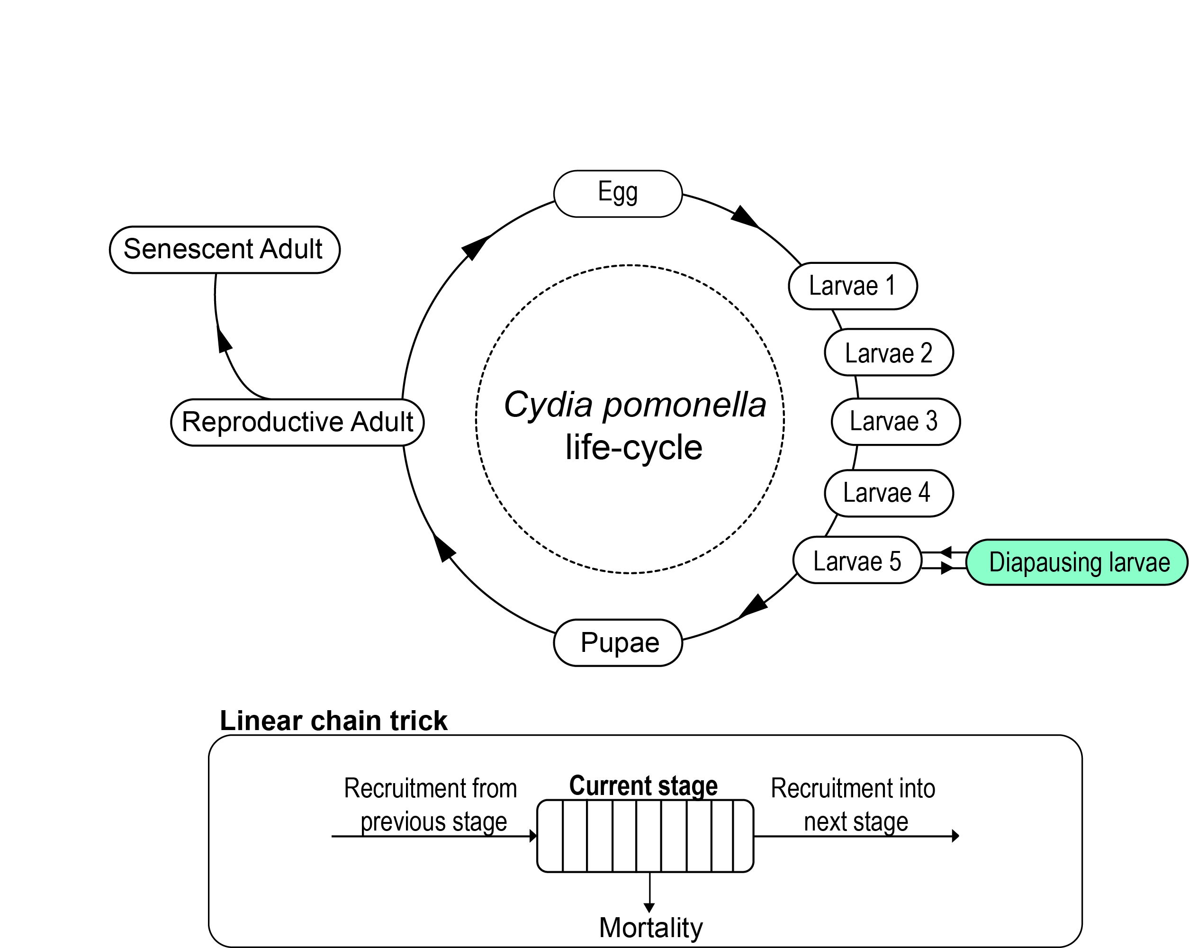

**Figure 2**

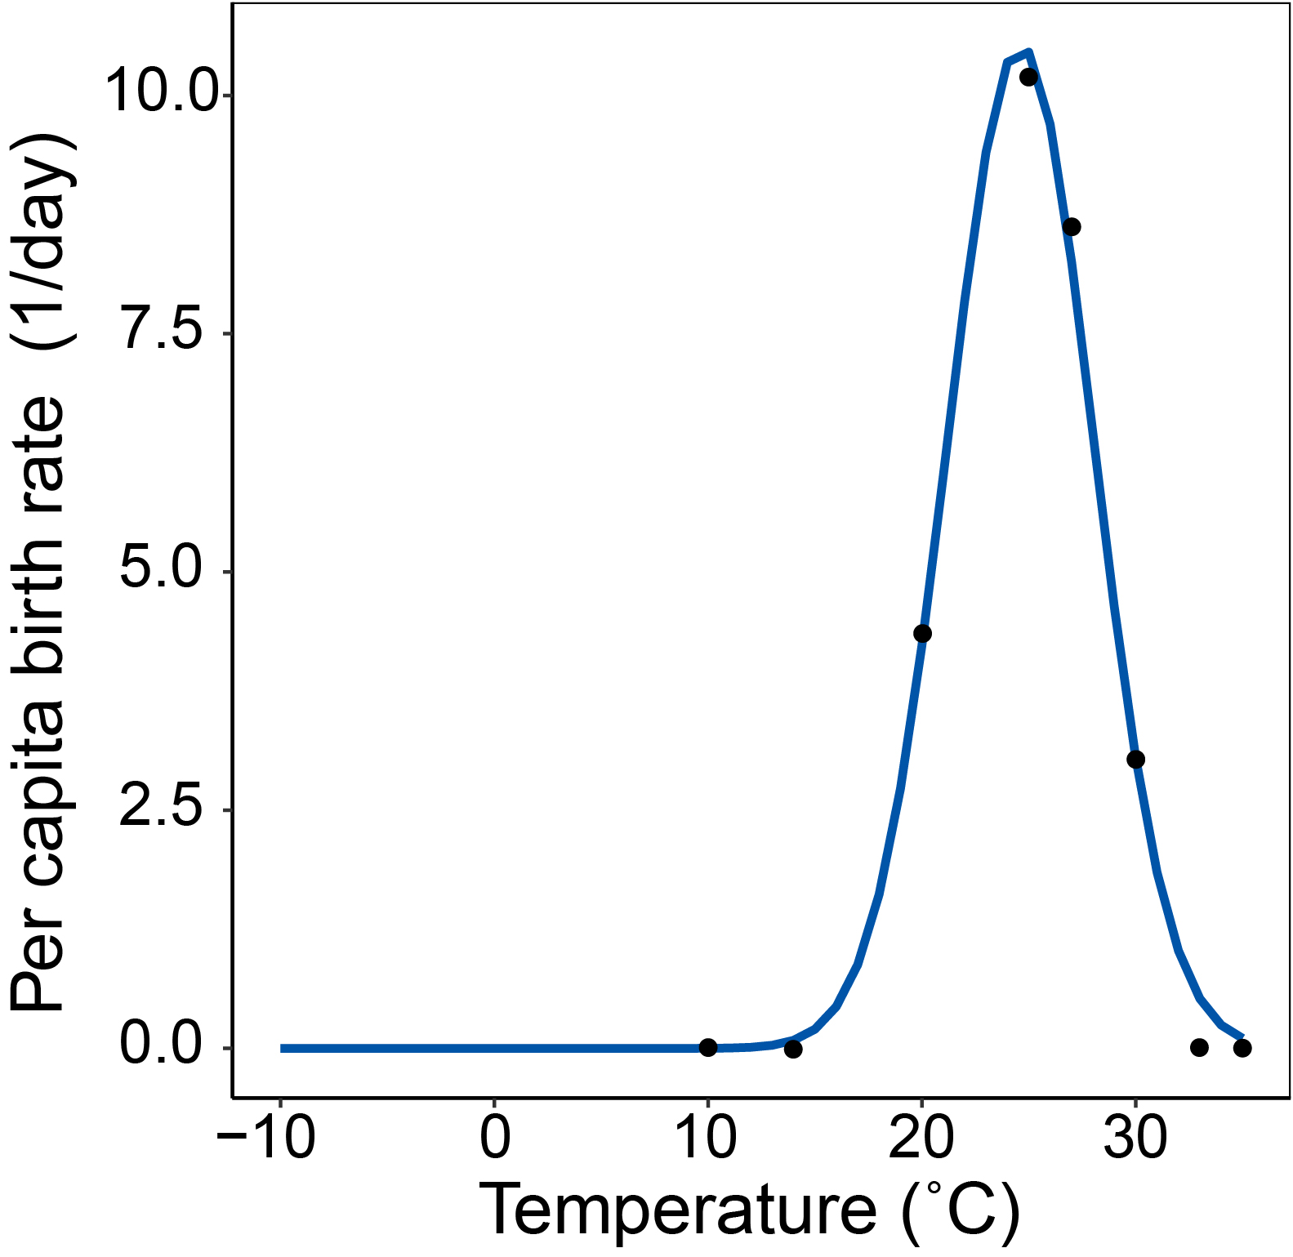

**Figure 3**

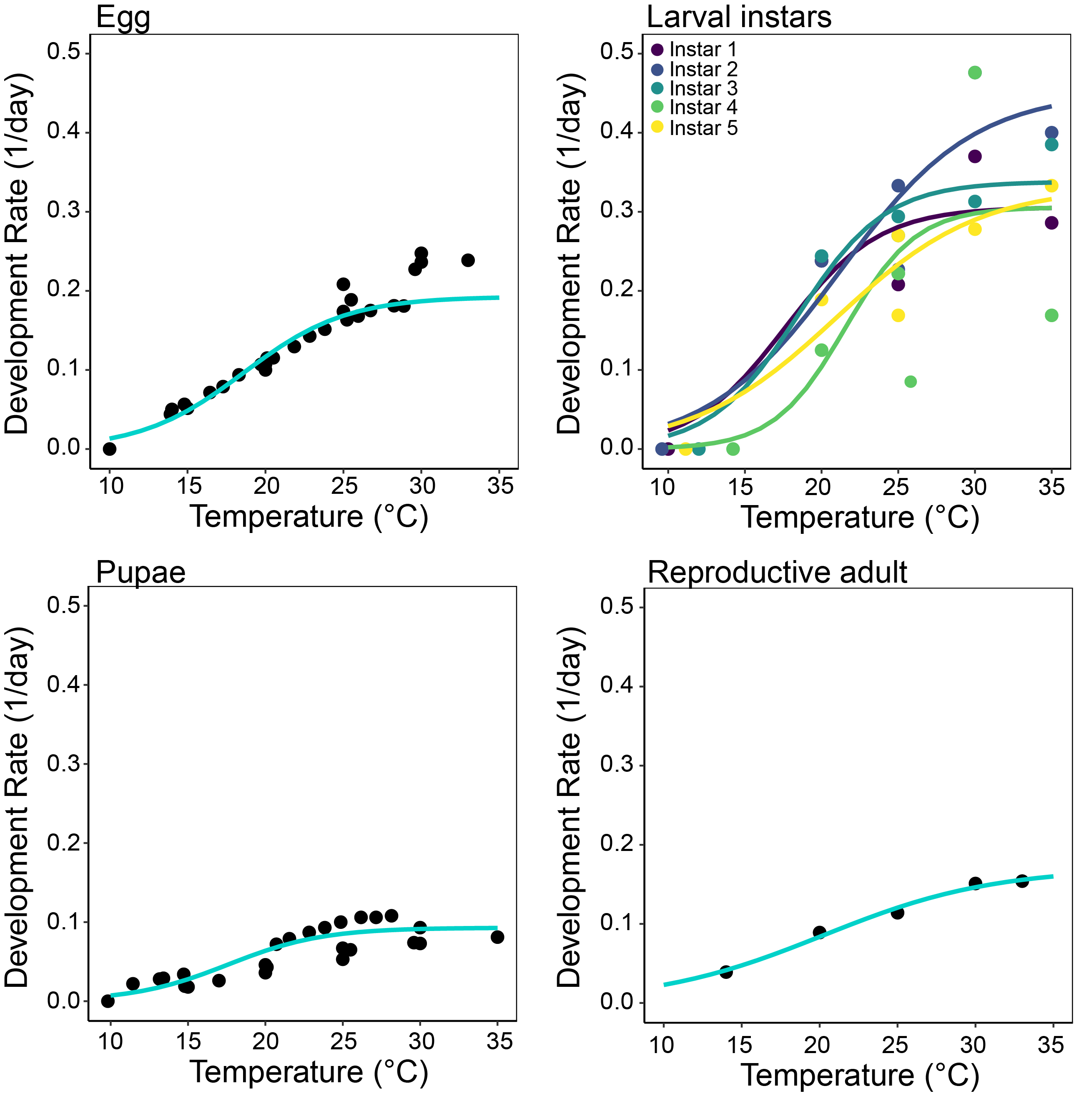

**Figure 4**

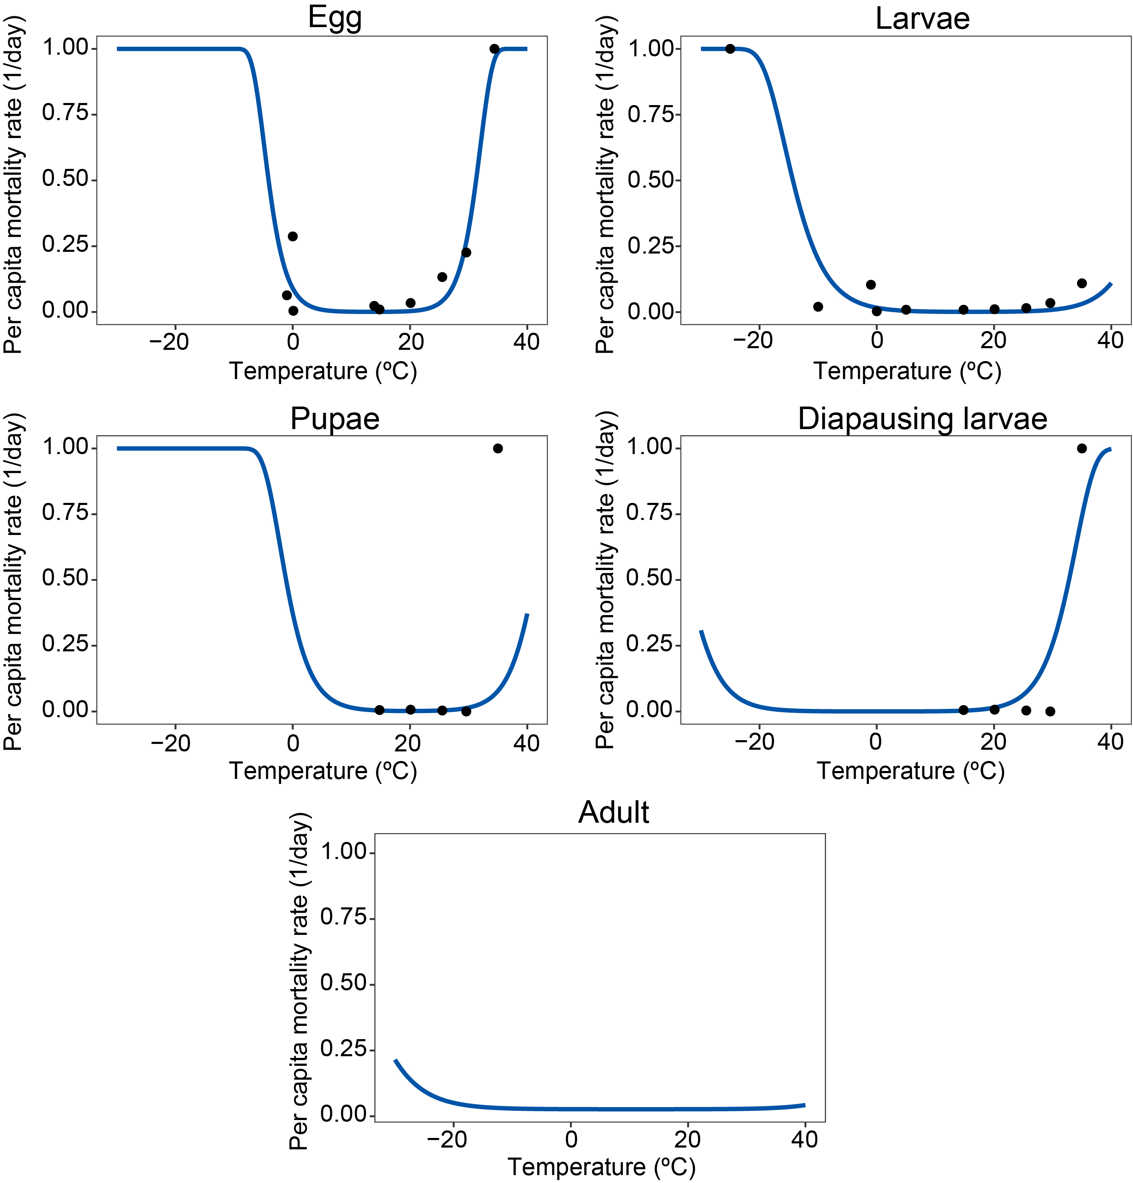

**Figure 5**

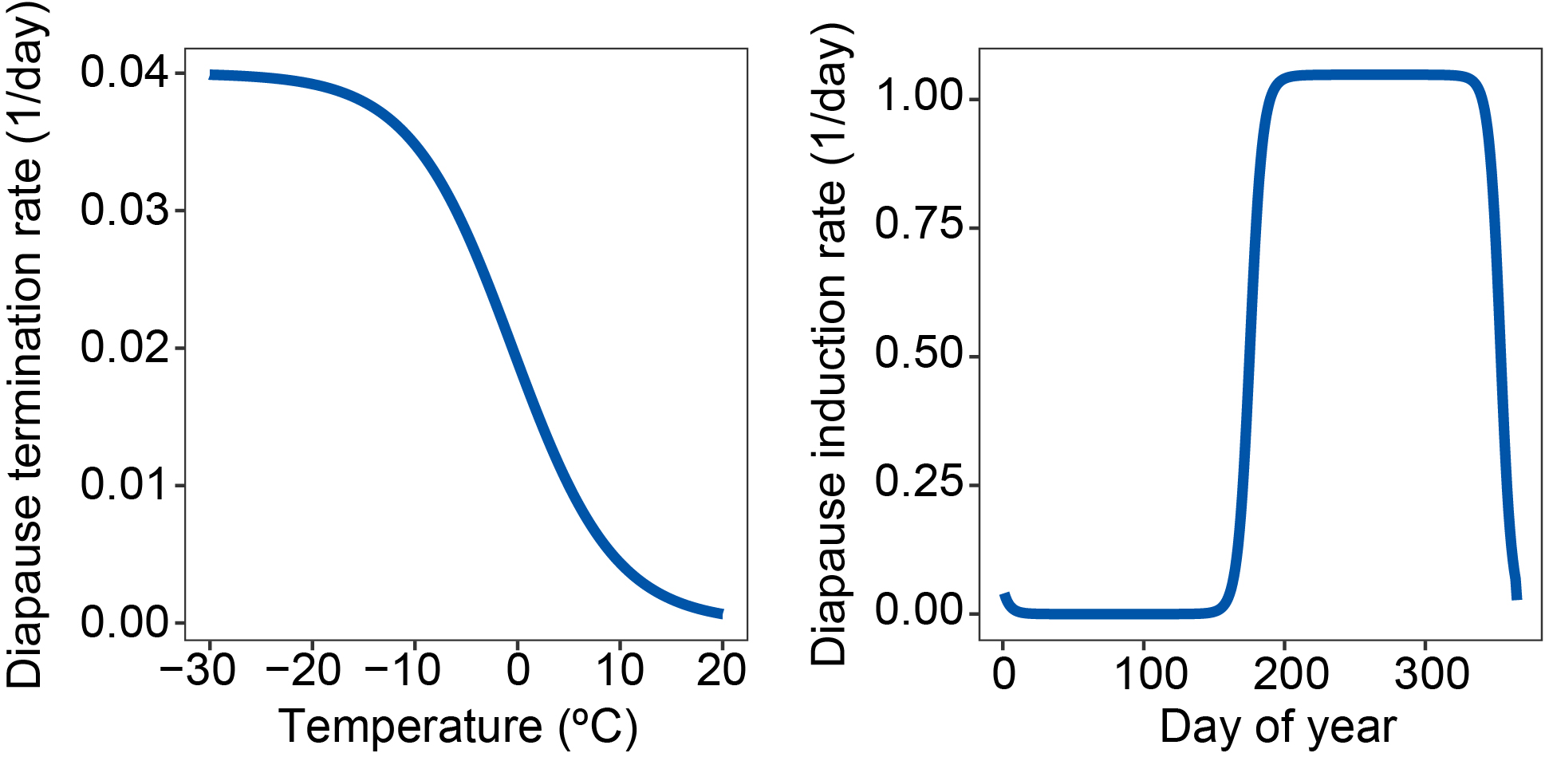

**Figure 6**

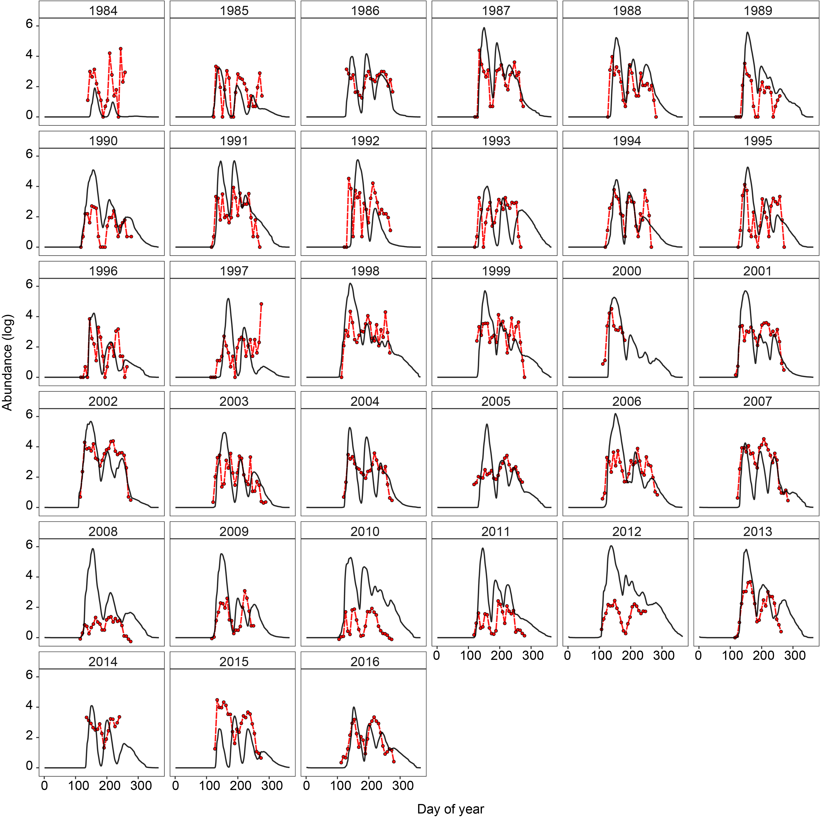

**Figure 7**



**Figure 8**



**Figure 9**

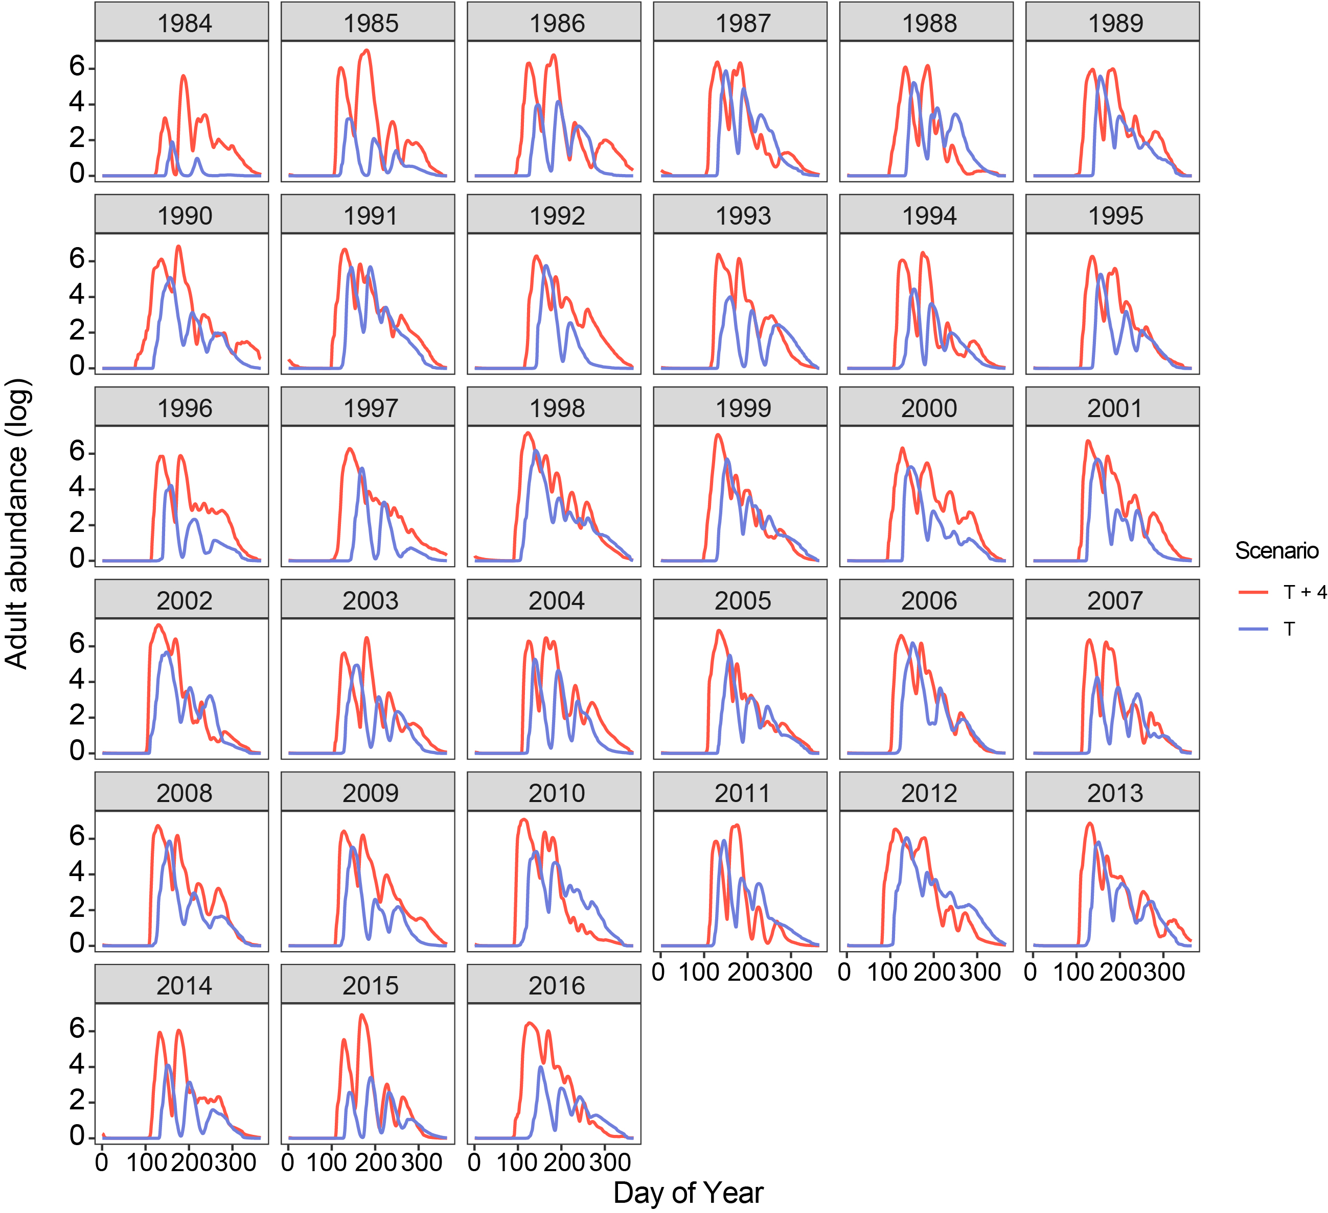

**Figure 10**



**Figure 11**

